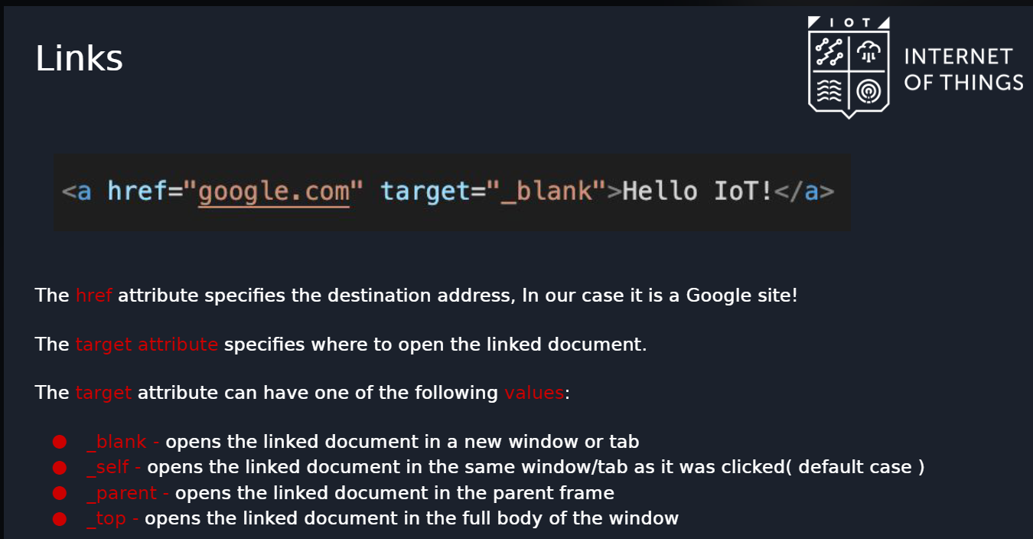

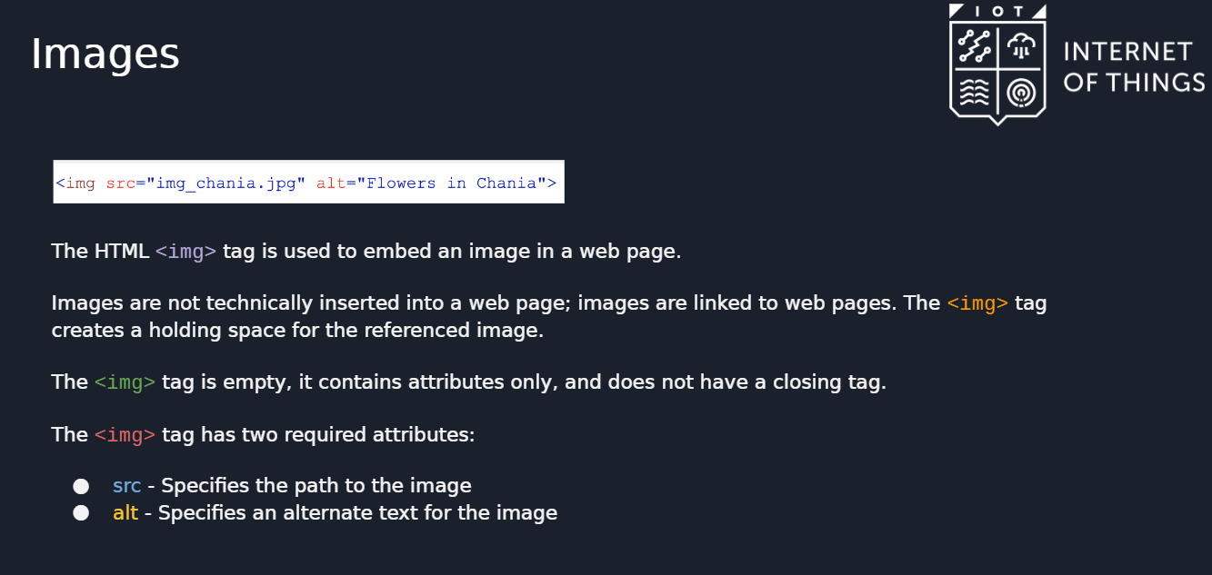

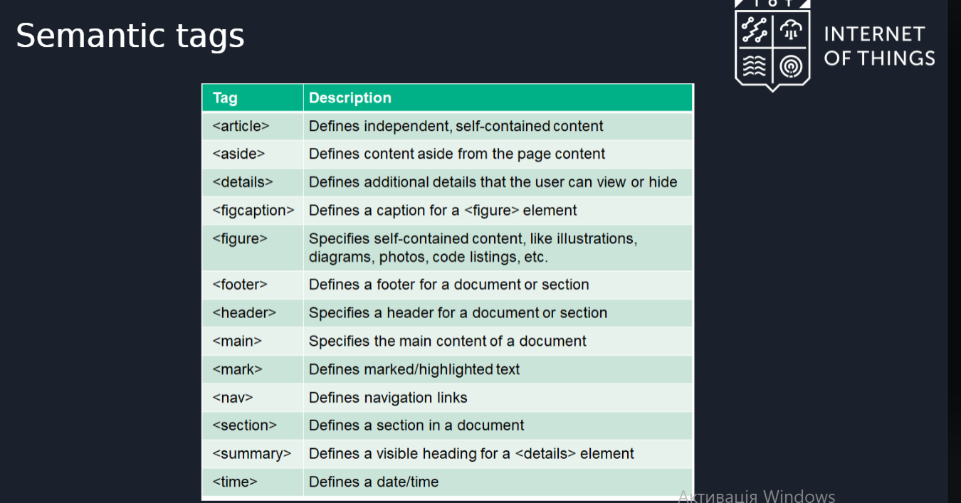

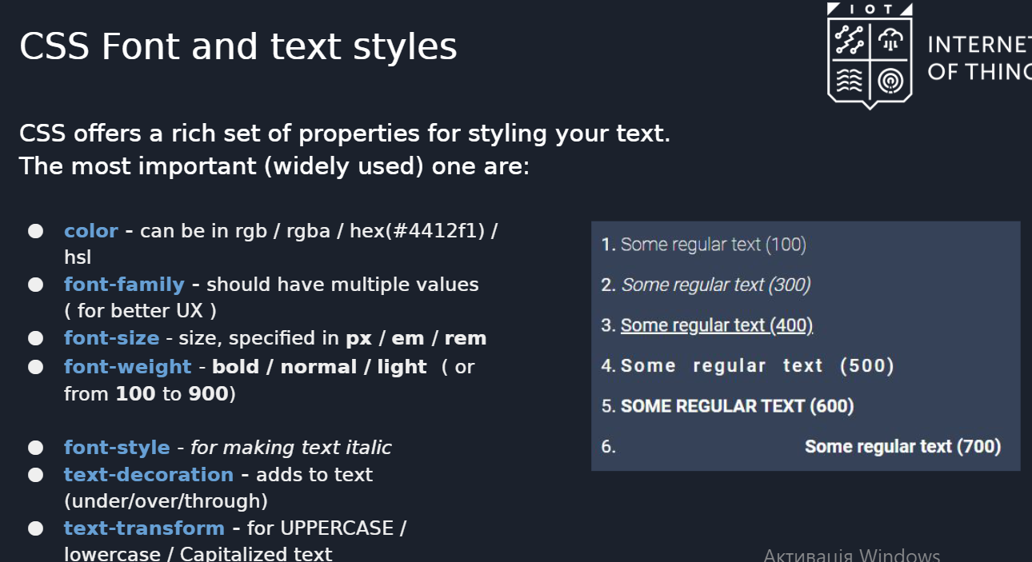

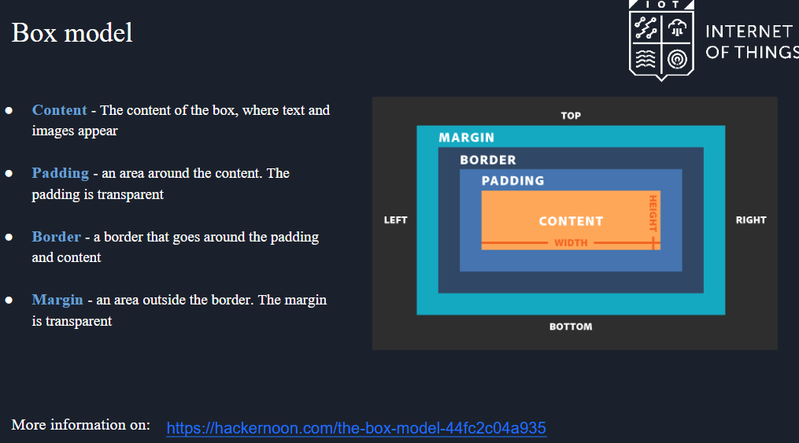

<https://hackernoon.com/the-box-model-44fc2c04a935>

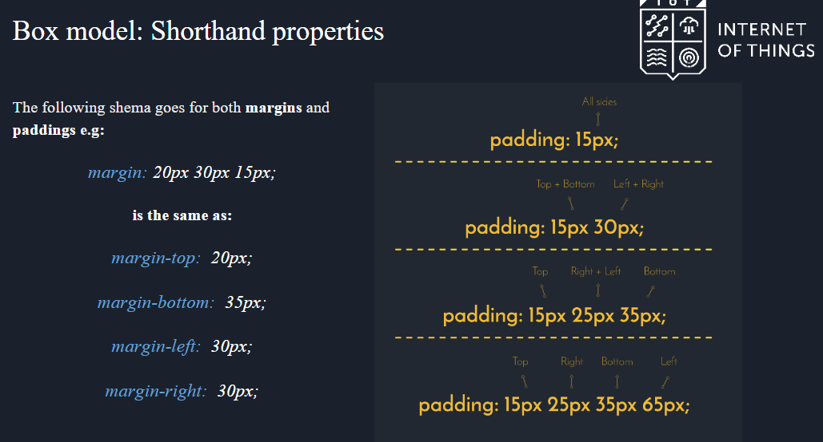

All about borders:

<https://developer.mozilla.org/ru/docs/Web/CSS/border>

Background styles:

https://css-tricks.com/almanac/properties/b/background/

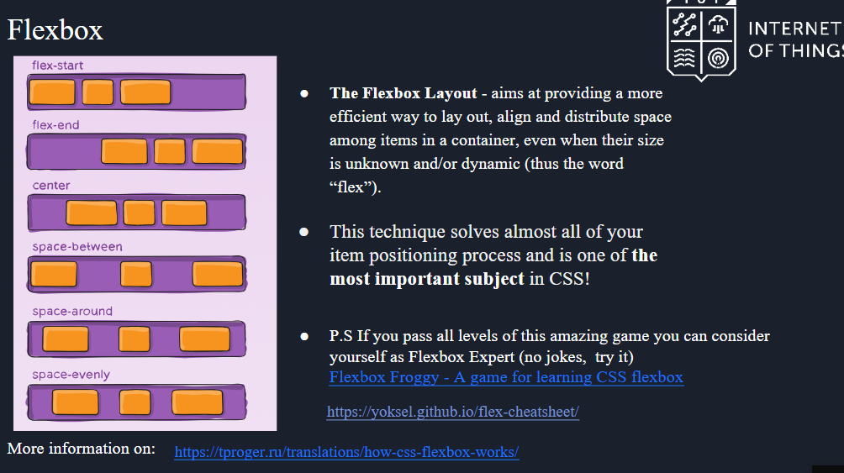

https://tproger.ru/translations/how-css-flexbox-works/

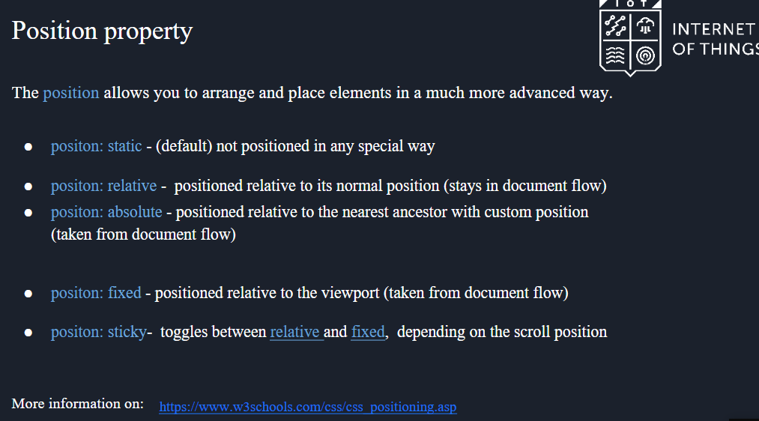

https://www.w3schools.com/css/css_positioning.asp

Псевдоелементи:

https://www.w3schools.com/css/css_pseudo_classes.asp